PROJECT DESIGN PHASE
Solution Architecture

Date | 1 November 2025
Team ID | NM2025TMID05413
Project Name | Educational Organisation Using ServiceNow
Maximum Marks | 4 Marks

Solution Architecture:
Goals of the Architecture:
- To design a centralized educational management system using ServiceNow.
- To automate the admission process and student data management.
- To integrate ServiceNow databases and workflow automation for real-time updates.
- To ensure secure data storage, analytics, and monitoring for educational operations.
- To provide a smooth interface for students, parents, and administrators.

Key Components:
- Admission Table (u_admission): Manages student admission records with status transitions (New → In Progress → Joined → Rejoined → Closed
→ Canceled).
- Integration Layer (ServiceNow IntegrationHub): Handles
communication between the Student/Parent interface and the ServiceNow database.

- ServiceNow Database (CMDB / Custom Tables): Stores all institutional data, including student, parent, and academic information.
- Analytics & Reporting: Generates reports for admissions, student progress, and system performance.
- Security & Monitoring Layer: Ensures data protection, user authentication, and system monitoring.
- Cloud Storage and Email Notifications: Sends alerts and admission updates automatically.

Development Phases:
- Set up the ServiceNow Instance – Initialize and configure the instance for development.
- Create Custom Tables – Build the Admission Table and related data structures for student and faculty records.
- Design Forms and Layouts – Customize forms for data entry and simplify the user interface for administrators.
- Implement Process Flows – Define workflows for admissions, updates, and approvals.
- Develop Client Scripts – Add automation, validation, and dynamic behavior to forms.
- Integrate with Cloud and Email Services – Enable notifications for admissions and progress updates.
- Apply Security and Monitoring Controls – Configure access control and performance tracking.
- Test and Deploy the System – Validate all workflows and ensure seamless data flow between components.

Solution Architecture Description:
The Educational Organisation Using ServiceNow solution architecture is designed to digitalize and automate the complete academic and administrative workflow of educational institutions. The system integrates various components like the Admission Table, Integration Layer, and ServiceNow Database to

create a unified platform that manages student admissions, progress tracking, and communication efficiently.
Students or parents access the system through a user-friendly interface, which interacts with the Integration Layer (ServiceNow IntegrationHub) to connect with the ServiceNow backend. The Admission Table records every admission status—from new application to closure—while ensuring data integrity and accuracy. All records are securely stored in the ServiceNow Database
(CMDB/Custom Tables), with automated workflows managing approvals, updates, and notifications.
The architecture also includes Analytics & Reporting modules for administrators to monitor institutional performance and Security & Monitoring layers to protect sensitive information. Cloud storage and email notifications enhance accessibility and communication.
This solution ensures automation, transparency, and scalability, allowing institutions to manage all their academic and administrative processes efficiently through a single, secure ServiceNow platform.

Example – Solution Architecture Diagram:
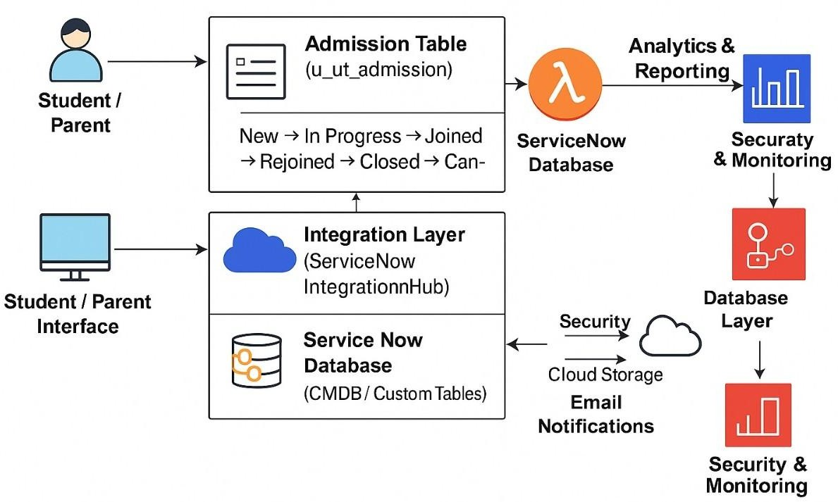
Figure 1: Architecture and data flow of the Educational Organisation Using ServiceNow application.

